#include<iostream>
using namespace std;
class Employee
{
public:
double Salary=60000;
};
class Programmer:public Employee
{
public:
double Bonus=5000;
};
int main()
{
Programmer obj;
cout<<"Employee Salary:"<<obj.Salary<<endl;
cout<<"Employee Bonus:"<<obj.Bonus<<endl;
return 0;
}
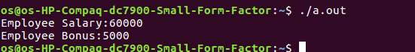

#include<iostream>
using namespace std;
class Employee
{
public:
double salary=60000;
};
class Programmer
{
public:
double bonus=5000;
};
class payment:public Employee,public Programmer
{
public:
void pay()
{
cout<<"Total Payment="<<salary+bonus<<endl;
}
};
int main()
{
payment obj;
cout<<"Employee Salary:"<<obj.salary<<endl;
cout<<"Employee Bonus:"<<obj.bonus<<endl;
obj.pay();
return 0;
}
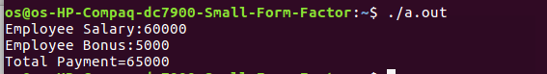

#include<iostream>
using namespace std;
class A
{

public:
int x;
void num()
{
cout<<"Enter value:"<<endl;
cin>>x;
}
};
class B:public A
{

public:
int y;
void num1()
{
cout<<"Enter value:"<<endl;
cin>>y;
}
};
class C:public B
{
public:
void add()
{
cout<<"Addition is:"<<x+y<<endl;
}
};
int main()
{
C obj;
obj.num();
obj.num1();
obj.add();
return 0;
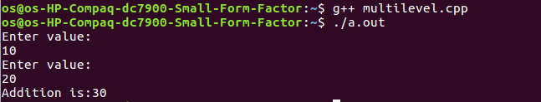
}
#include<iostream>
using namespace std;
class tree
{

public:
int x;
void num()
{
cout<<"Enter value x:";
cin>>x;
}
};
class B:public tree
{

public:
int y;
void add()
{
cout<<"Enter value y:";
cin>>y;
cout<<"Addition is:"<<x+y<<endl;
}
};
class C:public tree
{
public:
int z;
void mul()
{
cout<<"Enter value z:";
cin>>z;
cout<<"Multiplication is:"<<x*z<<endl;
}
};
int main()
{
B obj;
obj.num();
obj.add();
C obj1;
obj1.num();
obj1.mul();
return 0;



